**Lesson Demo**

**Using Custom Dates**

**Business Scenario:**

A sales manager has to submit a monthly sales report to her director. She needs to show the monthly trend in sales across various products. With the help of this analysis, the manager and her director want to reform their sales strategy for the next year. Create a highlight table with category, sales, and a custom order date showing data at the month level.

1. In August 2014, which category recorded the highest sales?
2. Which month in 2015 has the highest accumulated profit ratio across all product categories?

**Overview:**

1. Create a custom date on Order Date at Month/Year level
2. Create a Highlight table with Order Date (Month/Year), Category, and Sales
3. Add Profit Ratio to the tooltip
4. Sort months by profit ratio in descending order

The result should resemble the image given below:

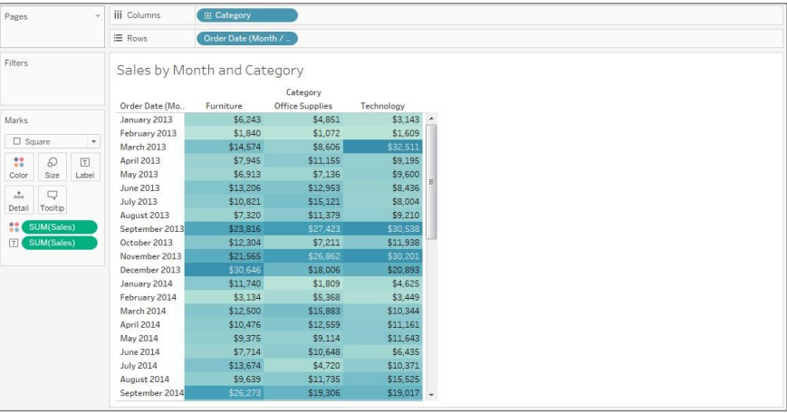

**Detailed Instructions:**

1. In the workbook from Exercise 10.1, click on **New worksheet** icon

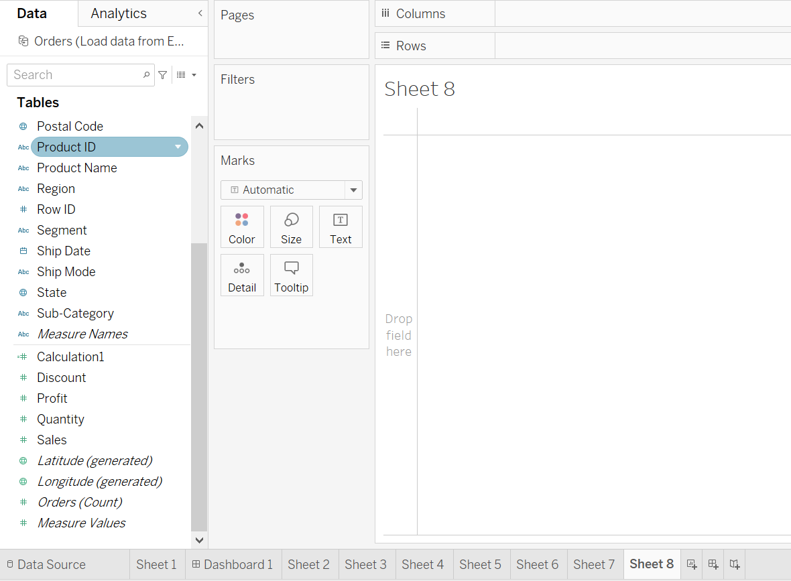

1. To create a custom date, right-click on **Order Date** dimension, and from **the Create menu**, select **Custom Date**

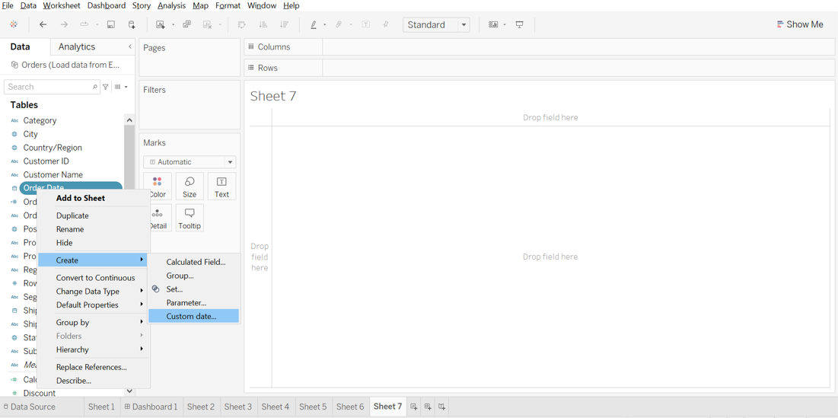

1. In the Create Custom Data [Order Date] window, choose Detail as **Month/Year** and click **OK**

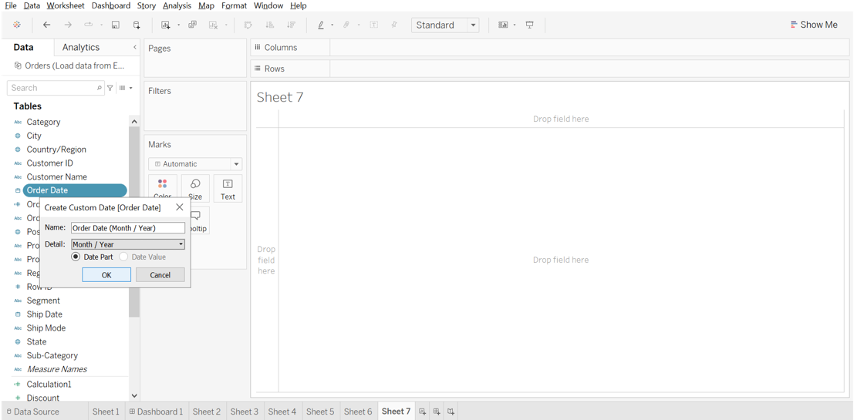 

1. This creates a new dimension: **Order Date (Month/Year)**

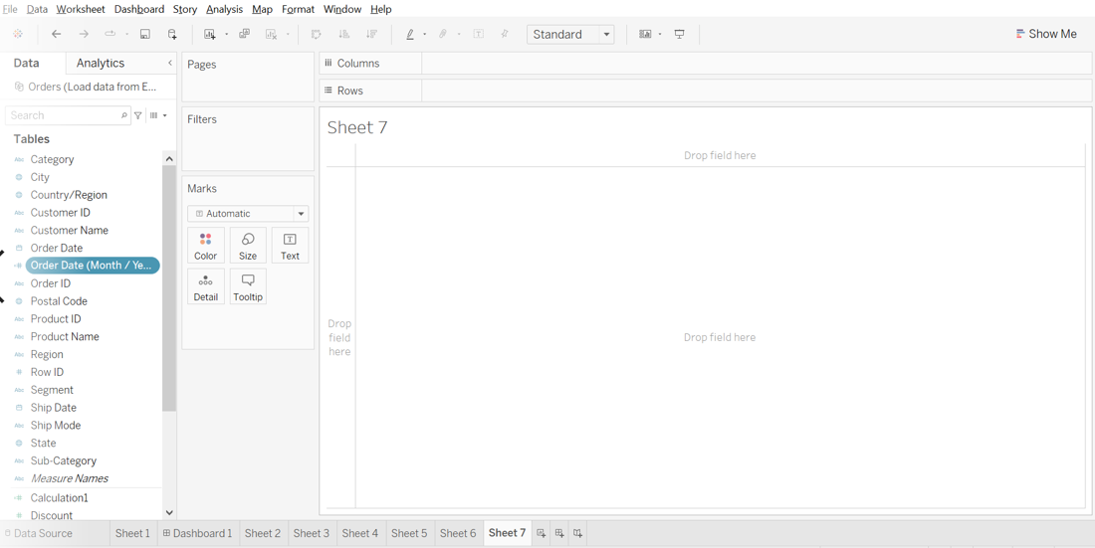 

1. Create a highlight text table with **Order Date (Month/Year)** in **Rows**, **Product Category** in **Columns**, and **Sales** in **text**

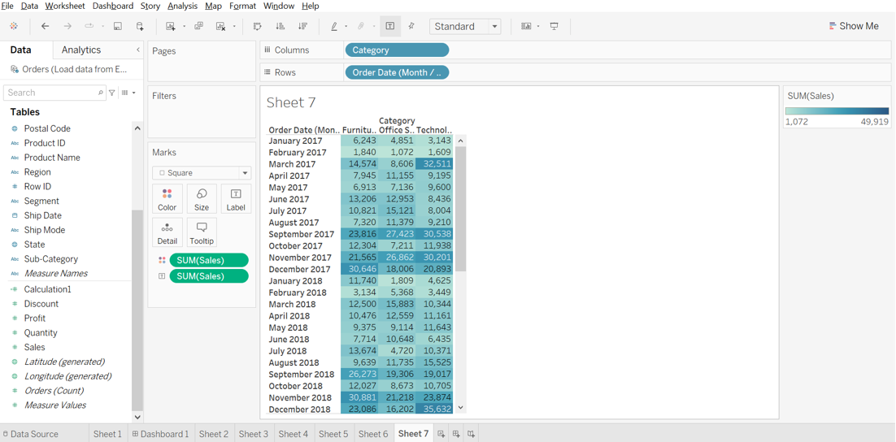 

1. Add **Profit** to the **Tooltip** shelf

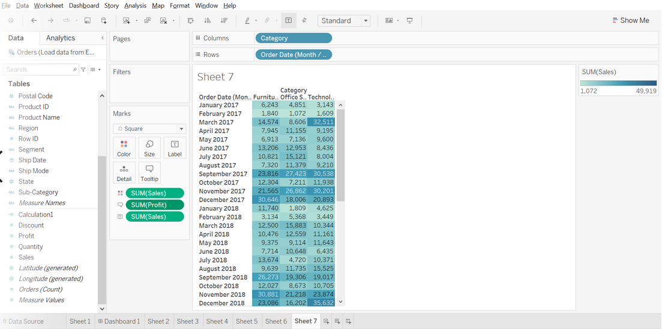 

1. Now, rename the worksheet as **Sales by Month and Category,** **Save** the workbook as **Lesson 10 Exercise**, and **Close** it

Based on the view, these are the answers to the questions in the problem statement:

• In August 2014, which category recorded the highest sales?   
 Answer: **Technology**

• Which month in 2015 has the highest accumulated profit ratio across all product categories?   
 Answer: **October**